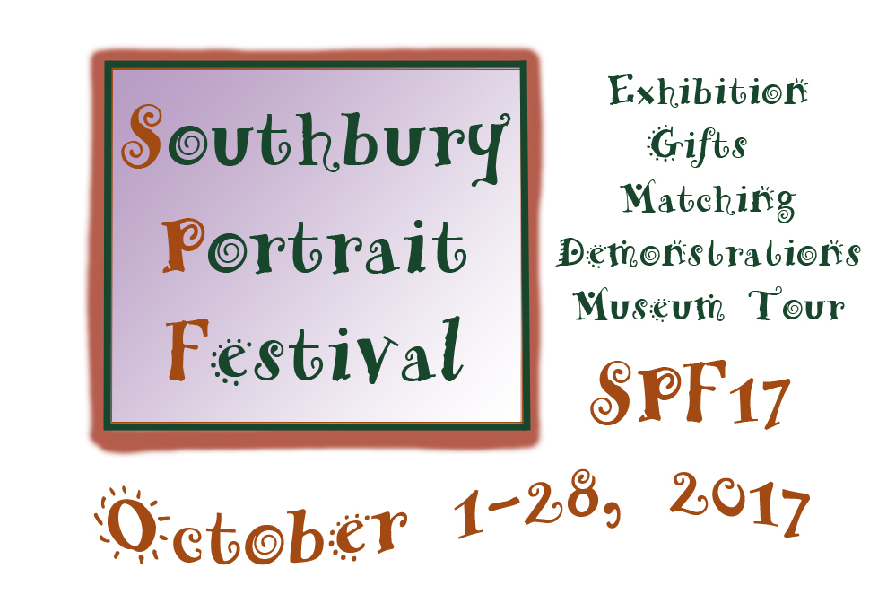
Artist Prospectus
CSOPA Members-Only Juried Portrait Exhibition and Events
Event Chairperson: ShawnaLee Kwashnak

In this day and age of technology, people are so used to instant results that they overlook 'real' art, the talent of these artists and how they can capture the beauty and personality of their subjects without technology. These portraits are heirlooms that can be passed down from Generation to Generation. I think people forget about commissioning portraiture because they don’t have the exposure or access to Portrait Artists. It will be AE’s goal to help advocate the work of CSOPA in October through our Gallery and our clients.
88 Main Street South
Southbury, CT 06488
203-586.1474

Arts Escape Executive Director, Becky Butler www.artsescape.org
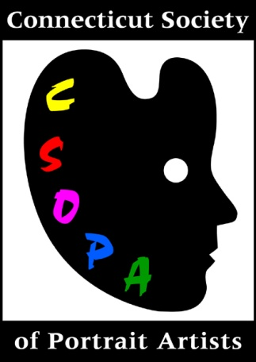
CSOPA is honored to partner with Arts Escape for SPF17. As part of our ongoing mission to promote the classic art of portraiture throughout Connecticut, we come to Southbury with a juried exhibition of members' work and outreach activities that involve the public. All CSOPA artists are Professional Ambassadors of Portraiture with a variety of opportunities to increase their exposure and interact with the community through exhibiting, demonstrating, and the creation of original works specifically for this event.
CSOPA Founder and President, Jeanine Careri Jackson www.csopa.org

Please read through the entire prospectus before making your selections.

Who: All CSOPA members are invited to submit. New members are welcome. Annual membership is $40. To check your member status, renew, or join CSOPA:
> log in to http://www.csopa.camp8.org or
> contact CSOPA Membership Director, Pat Boes: Memoriesinpastel@gmail.com.

Submission does not guarantee acceptance to the show. Only selected artists may participate in optional events where specified. Questions about SPF17 may be directed to Event Chair, ShawnaLee Kwashnak: artist@shawnalee.com
The selection committee consists of the CSOPA Board of Directors and Becky Butler, Executive Director of Arts Escape. There will be cash and gift awards. Juror tba.
*Volunteering is required in at least one capacity related to SPF17 in order to be considered for selection. Artists not participating in the exhibition are encouraged to volunteer as well. We ask that you specify how you plan to help out on the submission form. Your volunteer selections will be confirmed end-July.
What & Where: SPF17 Juried Exhibition of approximately 30 selected works, Opening Reception, Demos, Artists-in-Residence, Unveilings and Closing Ceremonies all take place at Arts Escape, Southbury, CT. This is a new facility with excellent lighting in a busy part of town.

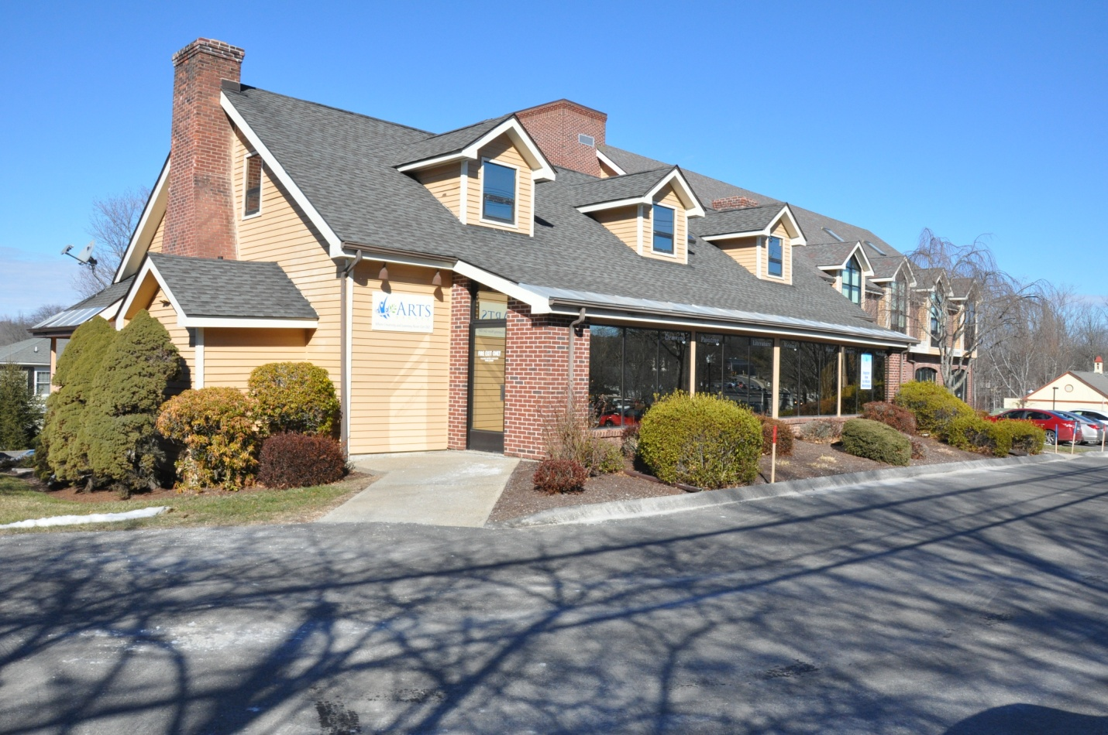

SPF17 Schedule and Events
*Starred events require your participation. All others are optional.
May 13, 12:30 pm -3:30 pm Meet 'n Critique at Arts Escape with Liaison, Ellie Boyd is your opportunity to see the space and review the SPF17 prospectus. All CSOPA members and your guests are invited to attend. Free. Bring Your Own Brown Bag Lunch. RSVP on submission form or by May 9 to Ellie: ellie@ellieboydstudio.com
*July 15 Submission Deadline Mail the attached form AND email entries. $25 for the first entry, $10 each additional. Maximum size 24" (height) x 18" (width) before framing; sculpture max 2' diameter including artist's stand. Selected Artists and Wait Lists will be emailed by the end of July.
August 12 Fundraiser at Private Estate During the Silent Auction at this off-site fundraiser, garden and gala guests will bid to win a Head and Shoulders portrait with a minimum bid of $500 payable directly to one CSOPA artist who will be chosen by the selection committee. Bid amount over $500 goes to the non-profit beneficiary, Arts Escape. There are no commission fees. To be eligible for auction selection, the artist must be willing to provide a framed sample, meet with the auction winner for sittings and studies, and produce a new portrait for the $500 Gift Certificate for unveiling October 28. If buyer wants a larger work, apply the GC to your price. Please indicate your interest on the submission form.
*September 30, 11 am - 1 pm Receiving Selected works must be delivered by the artists or their agents to Arts Escape properly framed, securely wired and ready for hanging 1-2pm. Sculptures must have their own stand.
October 1, 2 pm - 4 pm SPF17 Opening Reception, Awards, Holiday Giving, & Matching Program This is an opportunity for guests to meet our artists, purchase portrait gift certificates, and to preview samples of artists' work valued at the $500 mark for Matching Event (see below). Residents, community leaders, business professionals, teachers and clergy in and around Southbury will be invited by Arts Escape and CSOPA. You will also be given SPF17 invitations to distribute. > Reception CSOPA-Catered Event to be created by the Reception Committee. Public. Free. > Awards Juror, cash amounts and gifts tbd. Announcements at reception, 3:30 pm. > Holiday Giving Exhibition Holiday Panel Display and Reception Holiday Table feature Gift Certificates for Portraits that will be sold at Arts Escape throughout the festival. Each selected artist who expresses interest on the form below will be given several portrait packages to choose from. The Holiday Giving Panel remains on display throughout the show. Commission fees: 30% of certificate sales goes to ARTS ESCAPE and 10% to CSOPA. Artists will be paid 60% and receive details about the buyer at the time of the sale. > Match Artists agree to create an original head and shoulders portrait specifically for this event. The option to buy is one price for all: $500. There is no obligation for patrons to purchase, however acquisitions are expected. Unveilings of Match Portraits will be at the close of the show on October 28. Match Artists must be willing to use this opportunity to create a portrait with no guarantee to sell, set a fixed price of $500, describe the type of portrait a patron may expect for that price, provide a Match sample on submission form, and have the work completed for the October 28 Unveilings Ceremony. When a Match Program portrait is sold - or when any other work is commissioned - the artist retains 60%, pays commissions of 30% to Arts Escape and 10% to CSOPA.

NOTE: Participation in Holiday Giving or SPF17 Matching Program is not required to exhibit. There are no guarantees that participating artists will be selected by patrons, but you do have to be in it to win it!

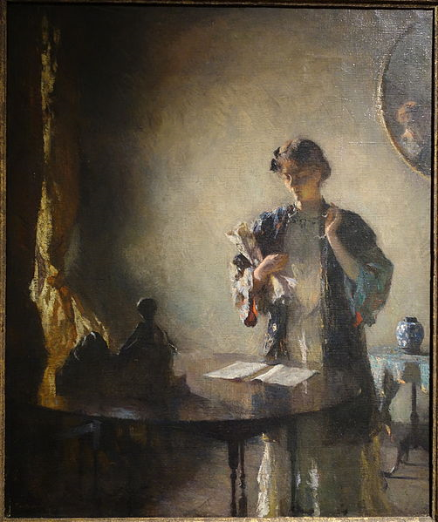
October, Monday through Thursday 10 am - 4 pm SPF17 Portrait Artists in Residence Program Get out of your studio! Selected artists wishing to gain additional exposure can request free studio time at Arts Escape during the month of October - by appointment. Work with your Match client, own model or from photos. Acceptance to the SPF17 Artist-in-Residence program is subject to availability. Free and open to the public to watch you work. Model stand and lighting on site for one artist at a time. Additional information will be provided to those who indicate an interest on the submission form.
October 5, Thursday Field Trip New Britain Museum for a special docent-lead Face-to-Face Portraits Tour. We meet at Arts Escape at 10am for SPF17 Tour, then carpools depart 10:30am. Group tour begins 11am at NBM. Seniors, students, and general public will pre-register to join us. Museum entry with tour is $15. An afternoon graphite copy session for SPF17 artists will be available for $5. Please let us know if this activity interests you on the submission form. Registration at SPF17 - New Britain Museum Tour.

Figure in a Room by Frank Weston Benson, 1912, oil on canvas at the New Britain Museum
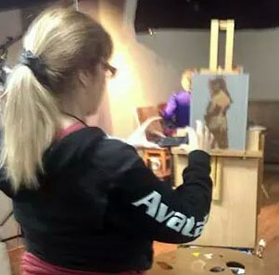
October 14, Live Demos 9 am - 12 pm and 1 pm - 4 pm Two selected artists who indicate interest on the submission form will be invited to work from life on site for an honorarium of $100 each. You will have the option of morning or afternoon session or both for one honorarium. The public is invited to paint along with you using their own supplies or just observe. Admission will cost $25. Net proceeds (after artist and model fees) will be divided between Arts Escape and CSOPA.
*October 28, Saturday Multiple Unveilings Ceremony (12-1pm) *Exhibiting Artist Pick-Up (1-2pm).
Commissions: 30% to Arts Escape, 10% to CSOPA on all portraits sold during or as a result of this show. Artists retain 60%. Sales are made directly by each artist who is responsible for paying commissions and collecting 6.35% CT sales tax on the amount they retain.
Example with a sell price of $1,000: An artist who sells a portrait for $1,000 will pay $300 to AE and $100 to CSOPA. At the time of the sale, the artist charges the client $1,000 + ($600 x 6.35%) = $1,038.10.
~~~~~~~~~~~~~~~~~~~~~~~~~~~~~~~~~~~~~~~~~~~~~~~~~~~~~~~~~~~~~~~~~~~~~~~~~~~~~~~~
SPF17 Calendar Summary
May 13, 12:30 pm -3:30 pm Meet 'n Critique at Arts Escape, Southbury
*July 15 Submission Deadline - Forms and Email Images
August 12 Fundraiser Off-Site
*September 30, 11 am - 1 pm Receiving & 1-2pm Hanging
October 1, 2 pm - 4 pm SPF17 Opening Reception, Awards, Holiday Giving , Matching Program
October, Monday through Thursday 10 am - 4 pm SPF17 Portrait Artists in Residence Program
October 5: New Britain Museum Tour & Copy Session
October 14, Live Demos 9 am - 12 pm and 1 pm - 4 pm
*October 28, Saturday Multiple Match Unveilings Ceremony (12-1pm) *Pick-Up (1-2pm).

Official Web Site: CSOPA.org > SPF17
Contacts: ShawnaLee Kwashnak artist@shawnalee.com Ellie Boyd ellie@ellieboydstudio.com

SPF17: Southbury Portrait Festival
October 1-28, 2017 at Arts Escape, Southbury, CT
CSOPA Members Only Juried Exhibition and Events
Office Use Only

ARTIST SUBMISSION FORM
*July 15 Deadline
Your Name _________________________________________
Email: ____________________________________ Cell Phone: _________________________
Address_______________________________, City_________________, State___ , Zip_______
I have read the prospectus schedule and events. Artist Signature ________________________
*MEMBERSHIP STATUS (csopa.camp8.org) I am a current member _________
Renew or Join Now for calendar year 2017 $40 _________

Acceptable Works: Original portraits in any medium. No photography or digital. Max size 24" (h) x 18" (w) before framing, 32" x 26" with frame. Sculpture with stands not to exceed 2' wide. Up to 6 entries. Match samples should be priced at $500. *Please complete this form AND email images per next page.

*ENTRY #1 Title ________________________________________________________ $25_________
Dimensions________(height) x______________, Medium________________
Price for Sale $___________ or Price for Similar $____________ Use as Match Sample? (Yes/No)_____

ENTRY #2 Title ________________________________________________________ $10_________
Dimensions________(height) x______________, Medium________________
Price for Sale $___________ or Price for Similar $____________ Use as Match Sample? (Yes/No)_____

ENTRY #3 Title ________________________________________________________ $10_________
Dimensions________(height) x______________, Medium________________
Price for Sale $___________ or Price for Similar $____________ Use as Match Sample? (Yes/No)_____

ENTRY #4 Title ________________________________________________________ $10_________
Dimensions________(height) x______________, Medium________________
Price for Sale $___________ or Price for Similar $____________ Use as Match Sample? (Yes/No)_____

ENTRY #5 Title ________________________________________________________ $10_________
Dimensions________(height) x______________, Medium________________
Price for Sale $___________ or Price for Similar $____________ Use as Match Sample? (Yes/No)_____

ENTRY #6 Title ________________________________________________________ $10_________
Dimensions________(height) x______________, Medium________________
Price for Sale $___________ or Price for Similar $____________ Use as Match Sample? (Yes/No)_____

Total Paid Online (csopa.camp8.org): $ _________ or Total "CSOPA" Check Enclosed $_________
SPF17: ARTIST SUBMISSION FORM

(Your Name __________________________continued)
*EMAIL ENTRIES to csopaentry@gmail.com. July 15 Deadline for email images. In the subject line, specify "SPF17". Type descriptions in the body of your message: Your First and Last Name, Title, Dimensions (height first), Medium, and Price for Sale or For Similar. Or, you may scan or use your smartphone to send a clear photo of submission form. Jpeg file size 300dpi. If selected, do we have your permission to use your images for promotional materials printed or online? Yes/No _____
OPTIONAL EVENTS & Volunteer Opportunities General descriptions are in the prospectus (above). *You must volunteer at least once to be considered for exhibition. We can reassign if your schedule changes; however, we do need your commitment now to volunteer at least once. Selection is never required to volunteer. We will confirm your interest in SPF17 activities and in helping out after the Selected Artists List and Waiting List are distributed end-July.

I am interested in:
_______ May 13, 12:30 pm -3:30 pm Meet 'n Critique for all CSOPA members
Volunteer May 13 (help Ellie Boyd set up Meet n Critique)_______

_______ August 12 Fundraiser if Selected (Commission $500 Silent Auction)

Volunteer September 30, *Receiving (11am-1pm) and/or Hanging (1-2pm)_______

_______October 1, 2 pm - 4 pm Reception Open to the Public
Volunteer October 1 Reception Committee (Awards, Catering, Decoration, or Entertainment) ______

______ October 1, 2 pm - 4 pm Holiday Giving if Selected.
Volunteer to assist with Holiday Giving Program (Displays and Custom Certificates) _______

_______ October 1, 2 pm - 4 pm Matching Program if Selected .
Volunteer to assist with Matching Program _______

_______October 14, Live Demos & Workshops 9 - 12 and 1 - 4 . $100 each for 2 Selected Artists.
Volunteer to assist with Live Demos _______

_______ October, Monday through Thursday 10 am - 4 pm Portrait Artists in Residence Program
If selected, which weekday(s) would you prefer? ___________________ am/pm/or both? ________
Volunteer to help coordinate the Portrait Artists in Residence Program _______

_______October 5 The New Britain Museum Face-to-Face Portraits Tour. Morning Tour Open to All. _______ Afternoon Copy Session for Several Selected Artists Only. (Pre-register at SPF17-Museum Tour)
Volunteer to help organize the Museum Tour & Copy Session _______

________October 28, Saturday Unveilings Ceremony 12-1. (*All artists must pick up between 1 and 2.)
Volunteer to help on October 28, Saturday Unveilings Ceremony 12-1 and/or Pick-Up, 1-2. _________

Mail completed submission forms with payment to CSOPA Director, ShawnaLee Kwashnak, 59 Bioski Road, Middlebury, CT 06762. Selection lists will be emailed by the end of July. Good luck to all!

