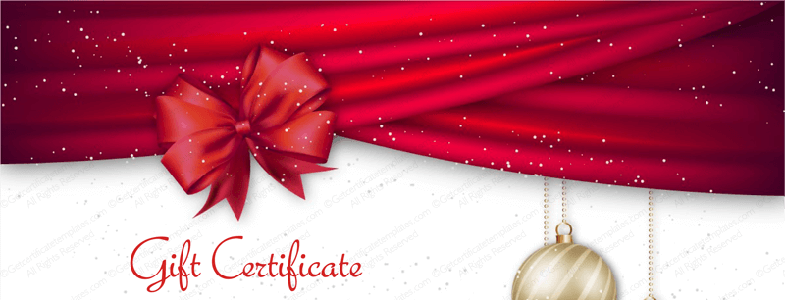
Artist 2022/23 Price List & Terms
For Single Figure Portraits. Please Complete and Email to csocietyopa@aol.com

ARTIST Contact Info: Name _________________________________
Address_________________________________________________
Email ___________________________Phone___________________

$250 Portrait Sketch in (check all that apply) up to 18” x 14”
___oil ___pastel ___charcoal ___graphite ____other (Specify):______
One to two-hour ______single sitting and/or ___from artist approved photo

$_____________ Head & Shoulders up to 20” x 16” (specify medium____)

$_____________Three Quarter up to 24” x 18” (specify medium____)

$_____________Full figure simple background up to 30” x 24” (specify medium____)

*Additional prices on request. Any gift may be applied towards a multi-figure portrait or portrait of greater value. Prices are valid up to one year from date of gift certificate. They do not include studies or photos, frame, travel beyond 10 miles, or sales tax where applicable. Allow up to 2 months to arrange initial appointment with your selected artist. Time to complete a portrait depends on complexity and artist availability.
Questions may be directed to the artist or
CSOPA: csocietyopa@aol.com, 203-856-4713 or 203-598-0065.
ARTIST COMMENTS, Additional terms, etc…
__________________________________________________________________
Gift certificates cannot be redeemed for cash. Neither CSOPA nor Stamford Art Association can be held liable for any dispute.

